4 . ReactJS-HOL

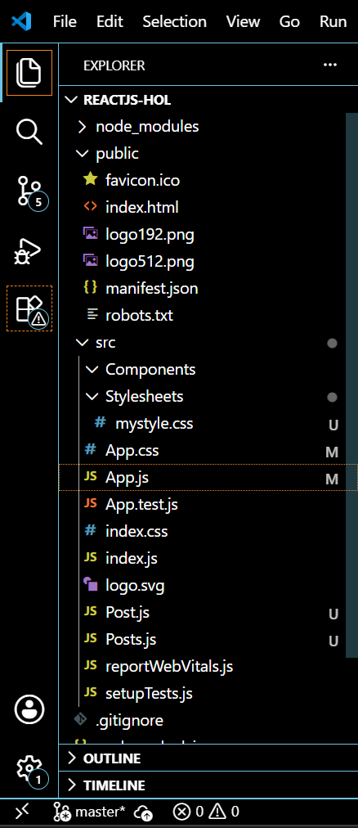

Post.js
class Post {
constructor(id, title, body) {
this.id = id;
this.title = title;
this.body = body;
}
}
export default Post;

Posts.js
import React from 'react';
import Post from './Post';

class Posts extends React.Component {
constructor(props) {
super(props);
this.state = {
posts: [],
error: null
};
}

loadPosts() {
fetch('https://jsonplaceholder.typicode.com/posts')
.then(response => {
if (!response.ok) {
throw new Error('Failed to fetch posts');
}
return response.json();
})
.then(data => {
const postList = data.map(item => new Post(item.id, item.title, item.body));
this.setState({ posts: postList });
})
.catch(error => {
this.setState({ error: error.message });
});
}

componentDidMount() {
this.loadPosts();
}

componentDidCatch(error, info) {
alert("An error occurred in Posts component: " + error);
}

render() {
const { posts, error } = this.state;

if (error) {
return <div>Error: {error}</div>;
}

return (
<div>
<h2>Post List</h2>
{posts.map(post => (
<div key={post.id}>
<h3>{post.title}</h3>
<p>{post.body}</p>
<hr />
</div>
))}
</div>
);
}
}
export default Posts;

App.js
import React from 'react';
import './App.css';
import Posts from './Posts';

function App() {
return (
<div className="App">
<h1>Blog Post List</h1>
<Posts />
</div>
);
}
export default App;

index.js
import React from 'react';
import ReactDOM from 'react-dom/client';
import './index.css';
import App from './App';

const root = ReactDOM.createRoot(document.getElementById('root'));
root.render(
<React.StrictMode>
<App />
</React.StrictMode>
);

App.css

.App {
text-align: center;
font-family: Arial, sans-serif;
padding: 30px;
background-color: #f9f9f9;
}
OUTPUT:

